OFFICIAL LEAGUE ROSTER - BASKETBALL
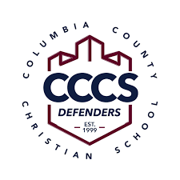

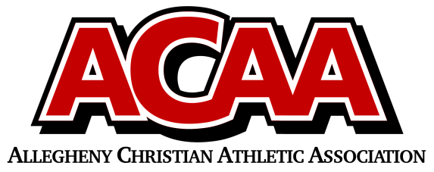

SCHOOL NAME: Columbia County Christian School
Head Coach: Kelli Boudman
Asst. coach: Torre Boudman

 | Number | Name | Year | Homeschool
 | 22 | Ashleigh Boudman | 12th
 | 12 | Erin Mood | 12th
 | 10 | Elizabeth Yocum | 12th
 | 14 | Audrey Mood | 11th
 | 3 | Isabella Farley | 10th
 | 2 | Lily Dumond | 10th
 | 15 | Lily Lenker | 9th
 | 25 | Elianna Engo | 9th
 | 1 | Isla Campbell | 7th

Official ACAA League Team Roster. to be submitted to the scorer’s to table before each game.

